Title in bold (centred alignment, Times New Roman, 14pt)

Author name,¹ Author name ,² Author name³ (Times New Roman, 12pt)

Affiliation, address, and country (Times New Roman, 12pt)
Author’s e-mail address (Times New Roman, 12pt)

Please prepare the abstract within an A4 page-format in compliance with the instructions given below.
For title, author name, affiliation and contact data, please follow the style of this abstract-template.
For body-text please use Times New Roman, 12pt, single-spaced throughout all body-text (i.e. without additional space between the paragraphs).
All abstracts must be written in English. A PDF file is accepted.
Each figure or table shall be directly inserted into the abstract and shall be provided with the relevant capture placed below the Figure or above the Table. The abstract-book will be handed out at the workshop in PDF format with password to participants.

Table 1. The 2nd International Workshop on Carbon Value Science & Technology  item  Date March 9th-12th, 2026  Venue: Tokyo University of Science  Organizer Carbon Value Research Center (CVRC), Research Institute for Science and Technology (RIST), TUS  Language English | 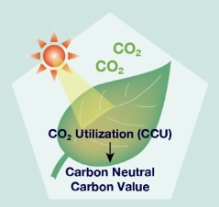  Fig. 1. Research topics

References should be written in Times New Roman, 12pt, and listed in the order they appear in the text (see below).

[1] F. Author, S. Author, T.H. Author, Journal, year, volume, page.
[2] F. Author, “ABC handbook”, publisher (city), year, page, doi

