Stereospecific Formation of Chiral Cytosine Crystal
by Dehydration from Achiral Cytosine·monohydrate Crystal

Hiroko Mineki,¹ Kenta Suzuki,¹ Yuko Hakoda,¹ Tsuneomi Kawasaki,^{2,1}
Kenso Soai^{1,2,}*

¹Department of Applied Chemistry, Tokyo University of Science, Kagurazaka, Shinjuku-ku, Tokyo, 162-8601 Japan. ²Research Institute for Science & Technology, Tokyo University of Science, Kagurazaka, Shinjuku-ku, Tokyo 162-8601, Japan. e-mail: soai@rs.kagu.tus.ac.jp

Cytosine is a nucleic acid base and is known as a prebiotic molecule. Crystal of cytosine obtained from MeOH belongs to chiral space group P2₁2₁2₁. Previously, we have reported the asymmetric autocatalysis using this chiral crystal [1].
However, cytosine recrystallized from water forms achiral crystal, which belongs to achiral space group P2₁/c.
We found the correlation between the shape of the crystal face and the chirality of resulting dehydrated crystal of cytosine. In the single crystal of cytosine monohydrate, there are two enantiomeric faces, which form parallelogram shapes (b¹- and b²-faces). The each crystal was heated from b¹- and b²-faces, respectively. The crystal heated from b¹-face was found to induce the negative cotton effect in the solid-state CD. On the other hand, the crystal that heated from b²-face exhibited negative cotton effect.
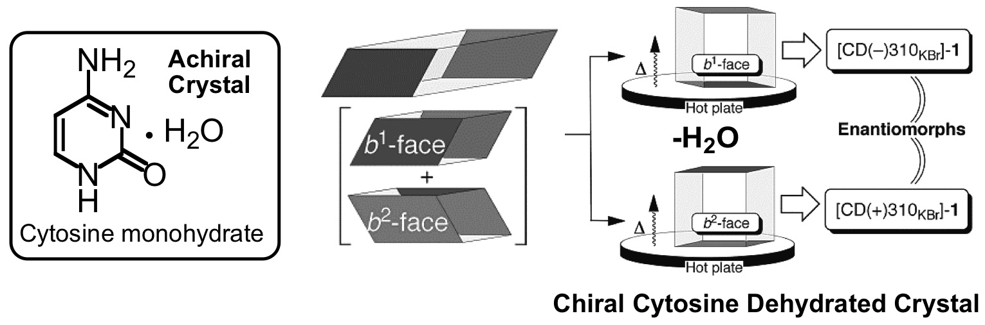
Using these crystals, we examined asymmetric autocatalysis. Cytosine crystal possessing positive cotton effect induces the formation of (S)-pyrimidyl alkanol with high ee. On the contrary, cytosine crystal possessing negative cotton effect induces the formation of (R)-pyrimidyl alkanol with high ee [2].
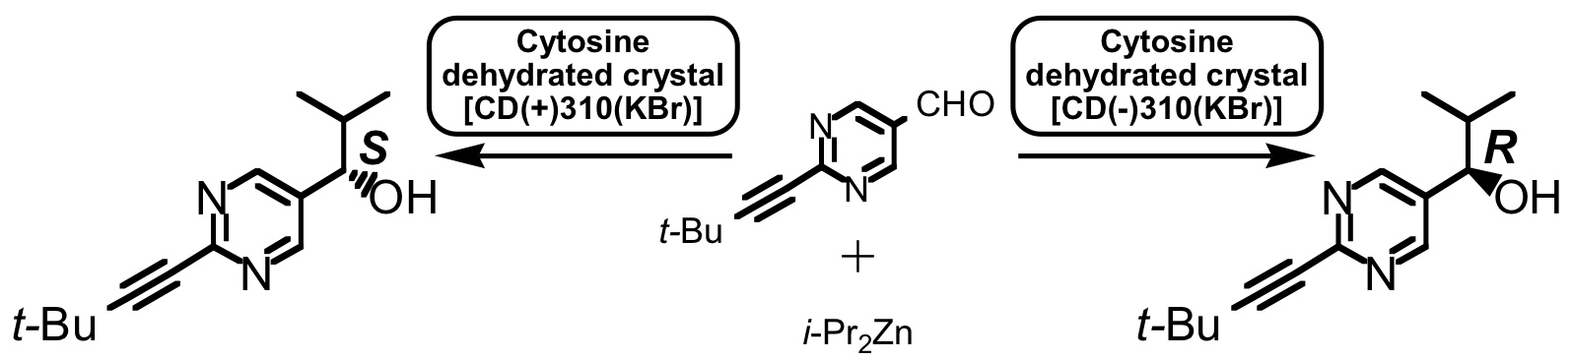

[1] Kawasaki, T.; Suzuki, K.; Hakoda, Y.; Soai, K. Angew. Chem. Int. Ed. 2008, 47, 496–499.
[2] Kawasaki, T.; Hakoda, Y.; Mineki, H.; Suzuki, K.; Soai, K. J. Am. Chem. Soc. 2010, 132, 2874–2875.

